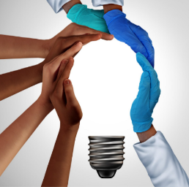


2022 Virtual T1 to T4 in 3 (Minutes) Challenge Recap

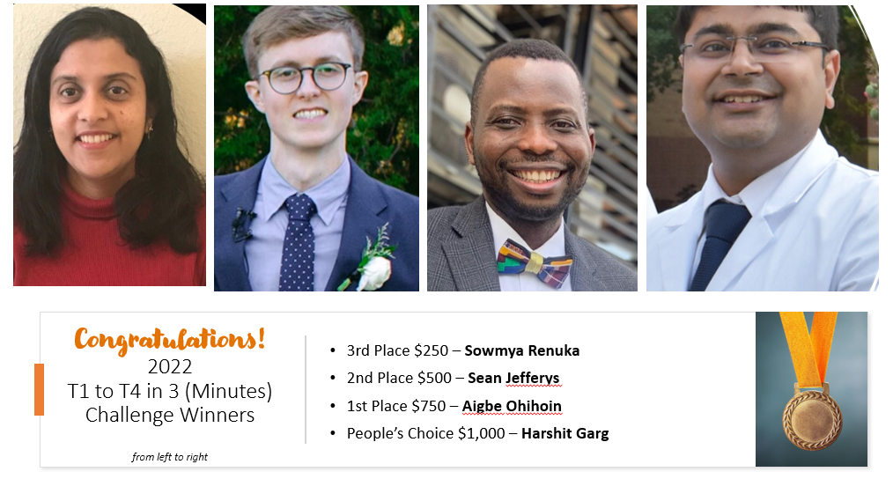
The IIMS hosted its 2022 T1 to T4 in 3 (Minutes) Challenge on June 22nd. This cross-collaborative event between the IIMS Community Health Advisory Board (CHAB), Community Engagement, and the Office of Research Education & Mentoring (OREM) gives community members and IIMS trainees a venue to present their research in 3 minutes to a live mixed audience of community members, faculty, staff and students. Presenters use language and concepts that are easy to understand with 1 slide.

Ten presenters (2 community and 8 OREM trainees) shared their research findings to 62 online participants. Winners included: Dr. Sowmya Renuka – South Texas Oral Health Network (STOHN) Practice Based Research Network (PBRN), Sean Jefferys – UTSA Translational Science PhD student, Dr. Aigbe Ohihoin – Translational Science PhD student, and Dr. Harshit Garg – Certificate of Translational Science student.
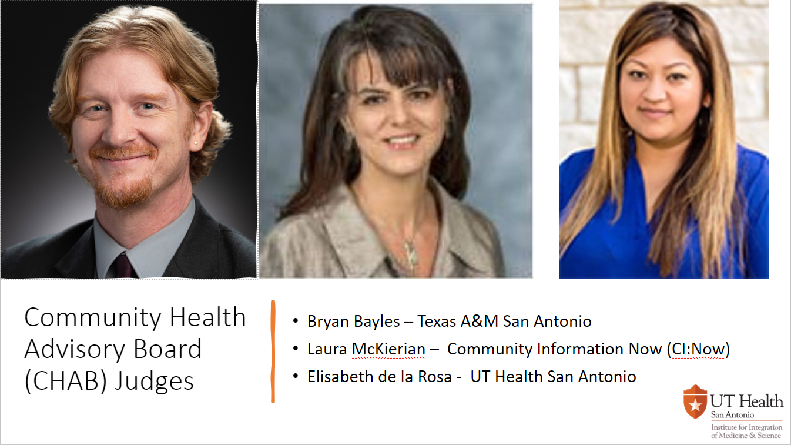

IIMS CHAB members Dr. Bryan Bayles – Texas A&M San Antonio, Dr. Laura McKieran – Community Information Now (CI:Now), and Elisabeth de la Rosa – IIMS served as judges. Together they selected the 1st, 2nd, and 3rd place winners. The audience selected the People’s Choice winner. Winners will receive awards for a professional conference and/or supplies. The IIMS appreciates the support of the attendees, judges, and presenters. Thank you all for a great event!

